**POC - Extracting unstructured data using Gen AI**

**Business solution:**

Extracting data from PDF files and images streamlines information retrieval, enhancing operational efficiency and enabling informed decision-making. Automation reduces manual effort, while structured data facilitates compliance adherence and fuels innovation through advanced analytics. Overall, data extraction empowers businesses to embrace digital transformation, driving agility and competitiveness in the modern landscape.

**Extracting data from pdf (English):**

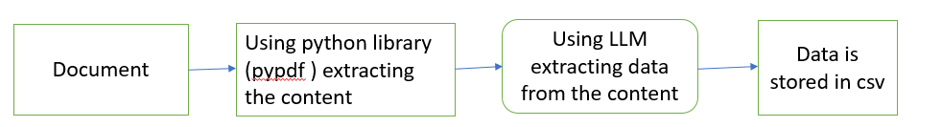

**Extracting data from pdf (Other than English):**

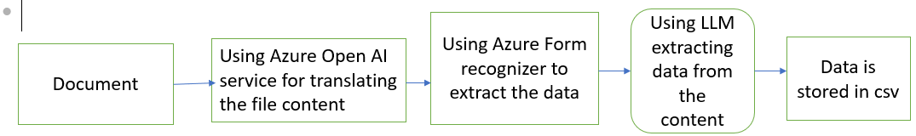

**Extracting data from images:**

